

# WEB-BASED APPLICATION DEVELOPMENT.

# SE102.3

## DATE OF SUBMISSSION: 21.01.2020

## LECTURER: Dr. Chaminda Wijesinghe

Team Members - SMART HEADS.

|  |  |  |  |
| --- | --- | --- | --- |
| INDEX | NAME | GIT HUB LINK | Role |
| 21007921 | K.G.T.U IMENDRA | https://github.com/tanushiumaya | Front-End developers.  Homepage body, Header, Footer.  Login interface. |
| 21009839 | H.D.D MADURANGA | https://github.com/Deshanm123 | Back-End Developers  Login developed by php, Database  developed by MySQL |
| 21009737 | U.W.D.H EHELEPOLA | https://github.com/afk98 | File submission and interface. |
| 21012688 | H.A DHARMADASA | https://github.com/hasi97 | Student accommodation interface. |
| 21012019 | M.J.D.M MINU | https://github.com/mjdmminu99 | Contact warden form  homepage slideshow |

* GITHUB REPOSITORY LINK:

https://github.com/Deshanm123/NSBM-HMS

# **CONTENT.**

1. Introduction.
2. Structure of the website.

* Home page.
* Student accommodation page.
* Login page.
* Contact us page.

1. Conclusion.

# Introduction

* In the developed website we mainly focus to the the hostel management system of the NSBM Green University Town. Our website is mainly focused on how to give a reasonable awareness to the students about the student accommodations inside the University premises.
* Our website will provide access to the students to receive a good knowledge about the premises. It provides the basic knowledge about the dormitories to our NSBM Students. Hostel management system offers a variety of facilities to the boarded students.
* We also provide special service in our website so that the students can directly contact the warden and the sub-wardens in case of emergency which ensures the safety and securement inside the premises.
* This can replace the following traditional procedure:

Traditional procedure of funding monthly payment is paying to the program office get the receipt, then give the receipt with student into warden in order to get hostel NFC card updated. so, both parties, student and warden get to experience benefits of simplification, and time saving.

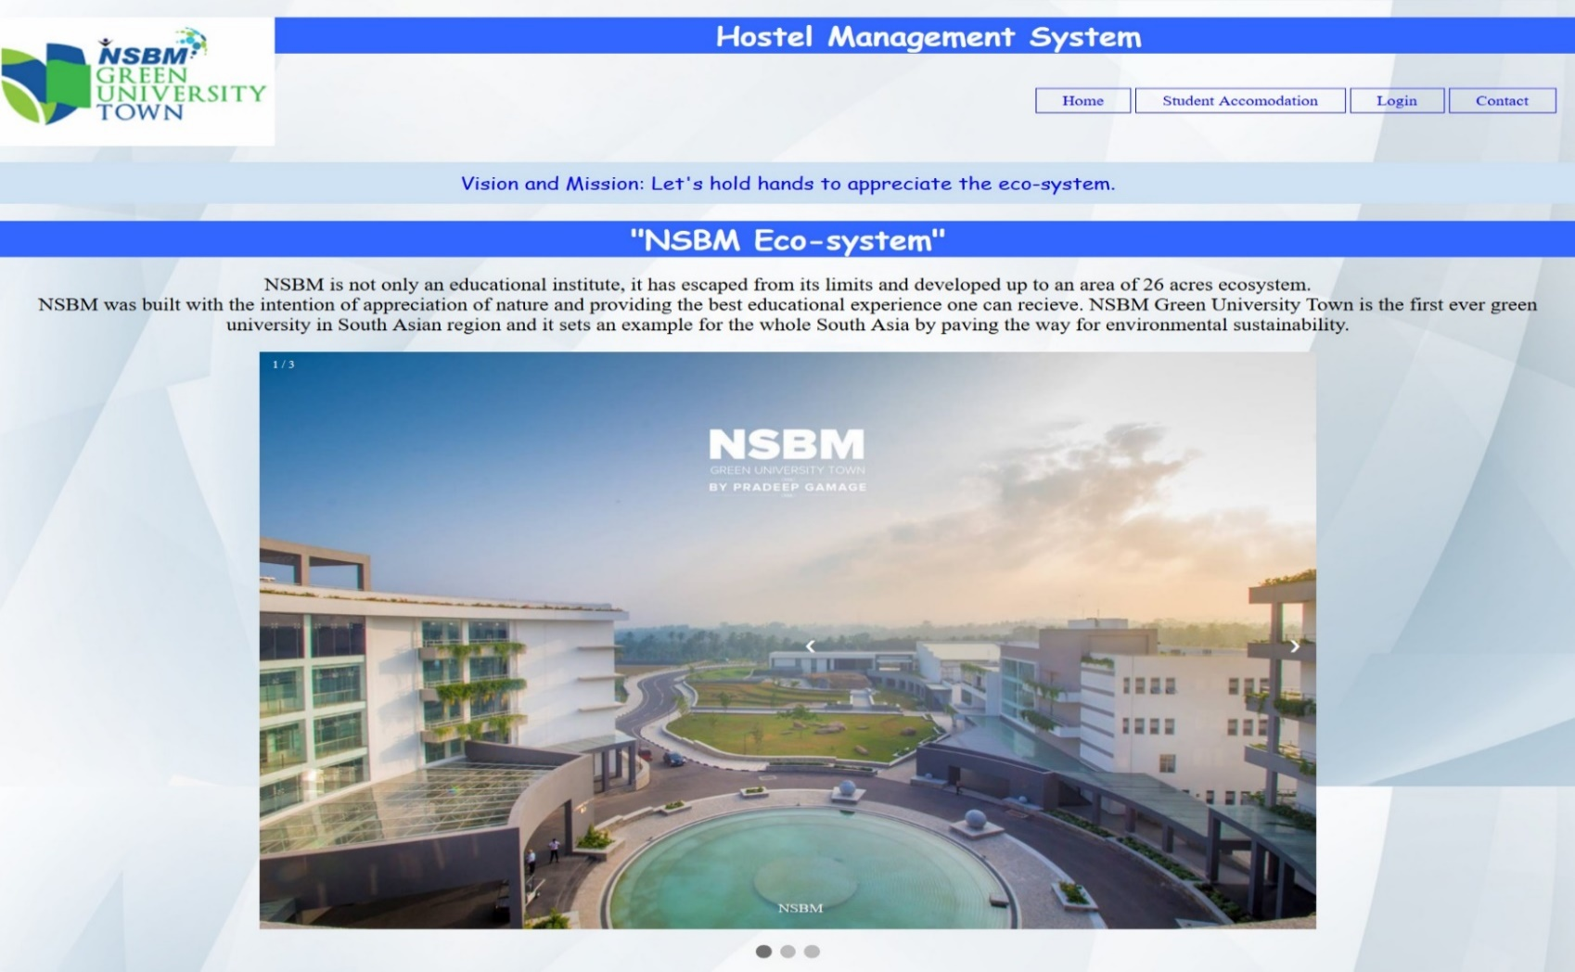

# Structure of the website.

## Home page.

* **Aim of this page:**

Basically, provide look over hostel premises to the students that are expecting accommodations.

Appreciating the community and green-environment.

* Home page mainly consists of the basic knowledge that one should have about the hostel management system in the NSBM green university community.
* In the left corner it consists of the NSBM logo which will project to the official NSBM home page when get clicked. At the top center in the header section we have the main topic “hostel management system” and right to the navigation bar which contains home, student accommodation, login and contact-us page. We provided a navigation bar for users to easily navigate inside the website.
* Home button direct to the homepage of the hostel management system while the Student accommodation button directs the page to the accommodation page. Login button directs to login page which give ability to get enrolled user information. And finally contact button directs the page to the contact information page. we can find the “vision and mission” in the center of the header section and below that we can see the movable photo gallery of the dormitory premises.
* Under the NSBM hostel topic, it displays a list of facilities and features that can be enjoyed by the hostel students and then little description about the academic and non-academic staff of the accommodation is stated.
* In the footer section, the NSBM logo, links to the 3 schools such as school of computing, school of business and school of engineering, links to the official Facebook page, email etc. is included.

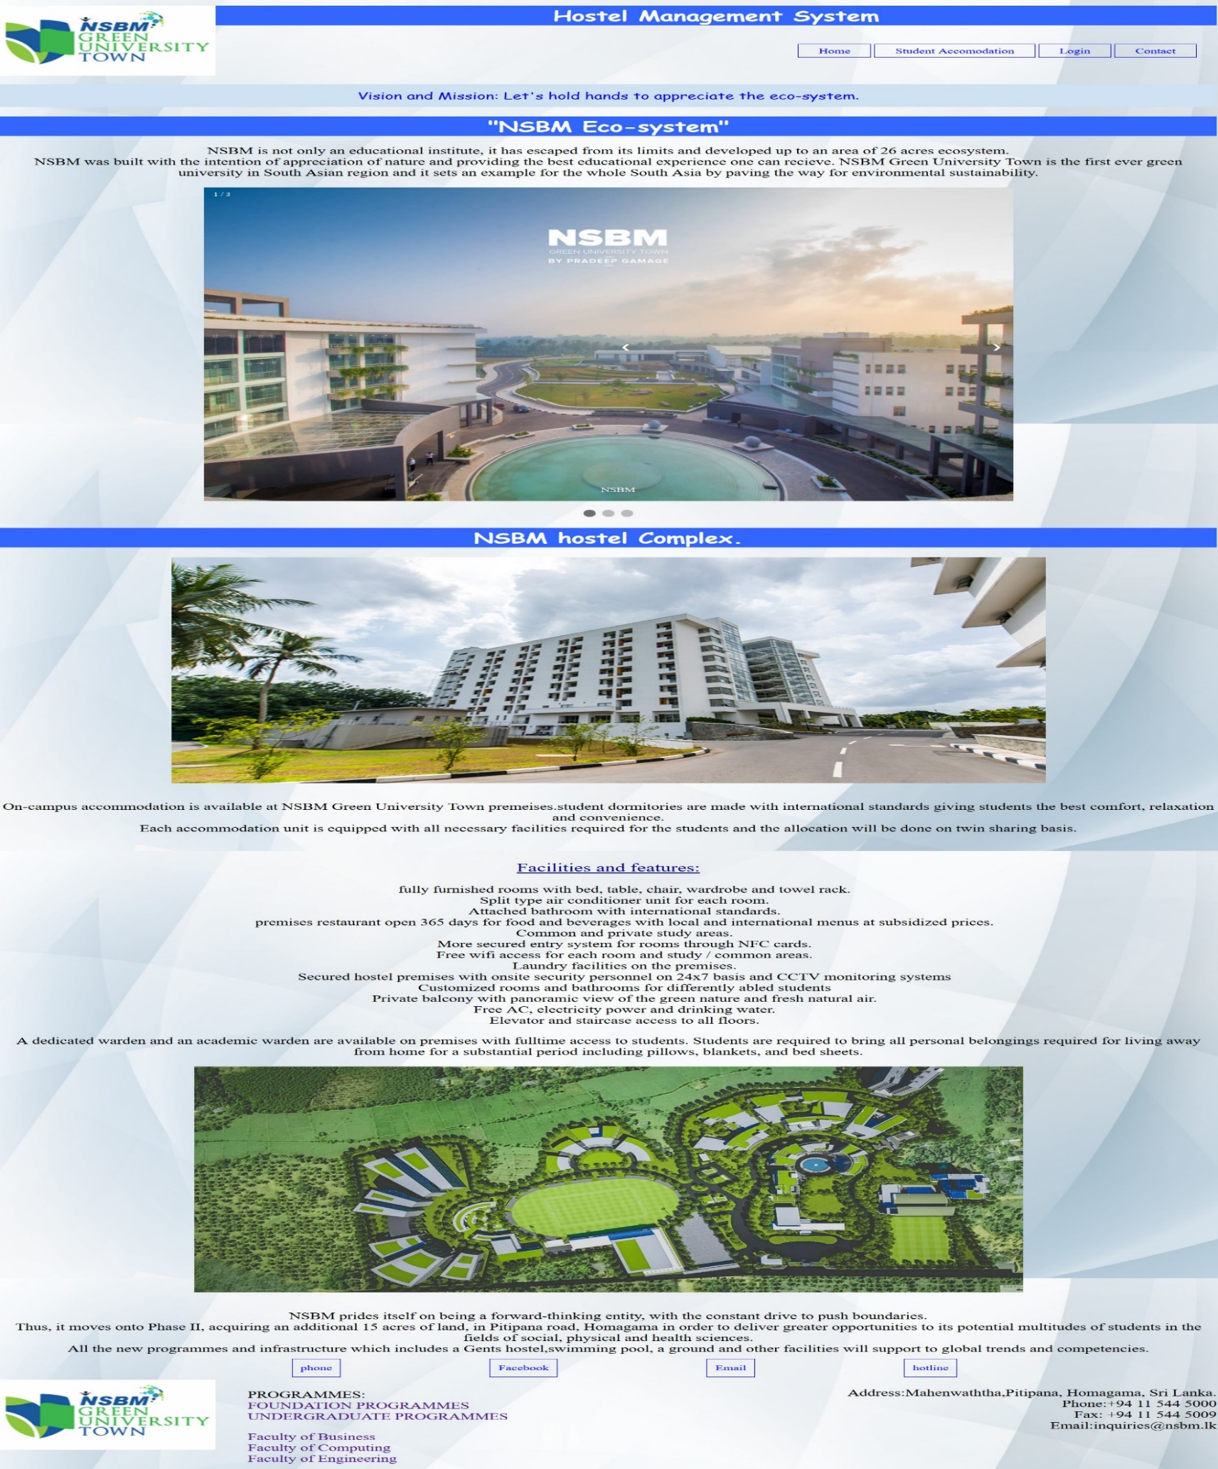

## Student accommodation page.

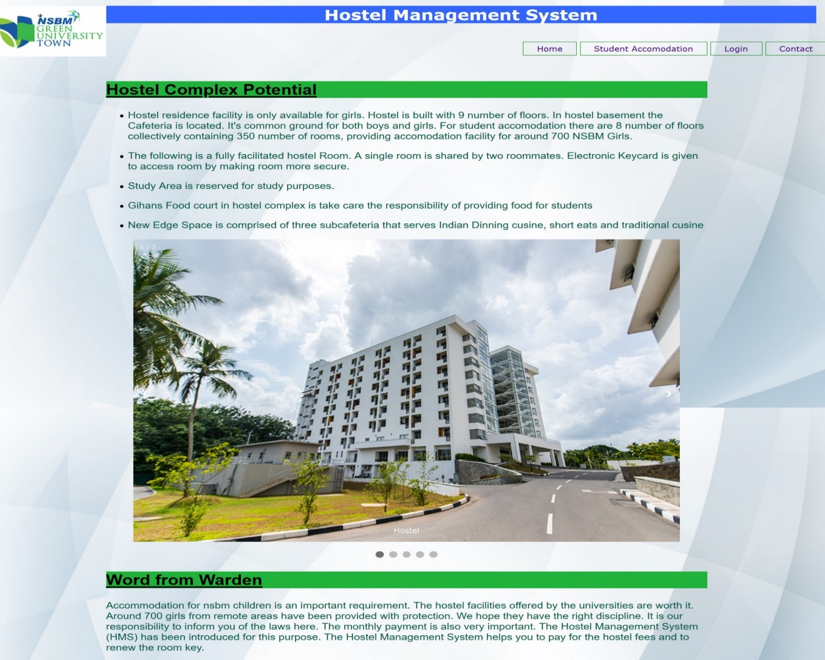

* **Aim of this page:**

This page provides information about facilities that can be consumed when students get enrolled to the hostel community.

* In the header section of the page, the NSBM logo and the navigation bar are present as usual. Student accommodation page is all about the description about the rooms and the facilities which students can engage. A friendly, caring staff consisting of wardens and onsite security personals are present on 24/7 basis.
* Swappable Photo gallery that include photos of NSBM rooms, are also included as well.

## 

## Login page.

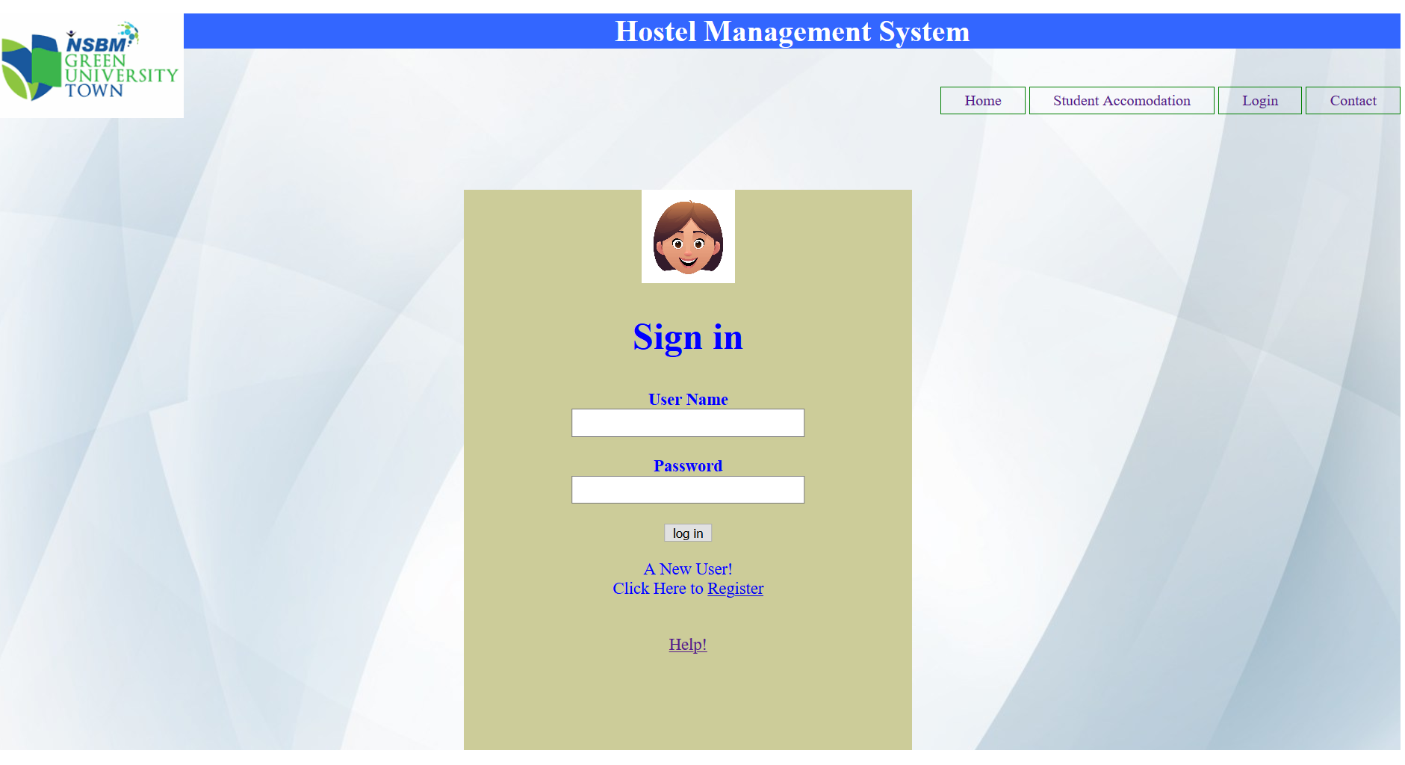

* When we input the user credentials it directs to NSBM database that show information like date of enrollment, date of payment to the hostel in each month etc. of the relevant user.
* If you haven’t signed up yet there’s the button to register to the page.
* Newcomers are registered through this hyperlink.
* A help button is placed in the bottom of the page to direct to the help page for any other requirement.
* Traditional procedure of funding monthly payment is paying to the program office get the receipt, then give the receipt with student into warden in order to get hostel NFC card updated. so, both parties, student and warden get to experience benefits of simplification, and time saving.
* In there you must keep hostel NFC card 24hrs with in warden’s office. This procedure can be simplified via using the database we have developed in this webpage.

After the specific user get directed to the welcome page It lets the system to escape from the traditional monthly payment procedure.

In there you must upload the digital imprint of the receipt to the web online instead of providing it to the warden. Online procedure makes this more efficient rather than the traditional path.

Step by step Procedure:

Requirements:

1.student ID.

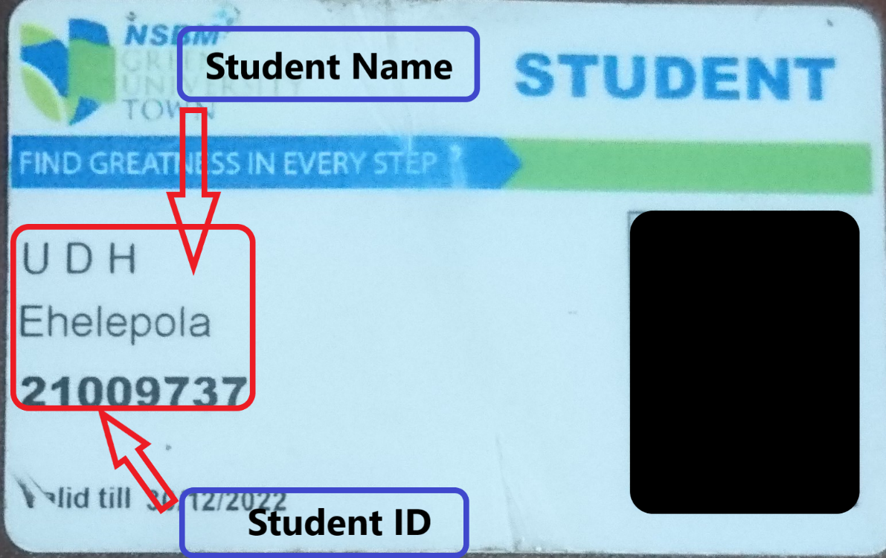

2.RECEIPT.

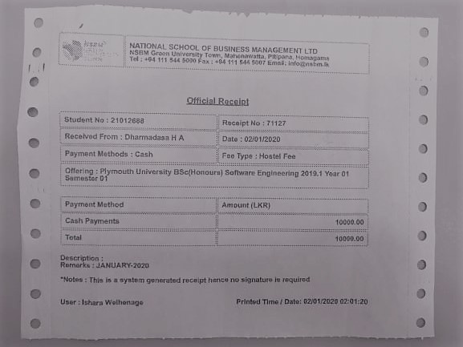

1ST STEP.

Inserting Required Data.

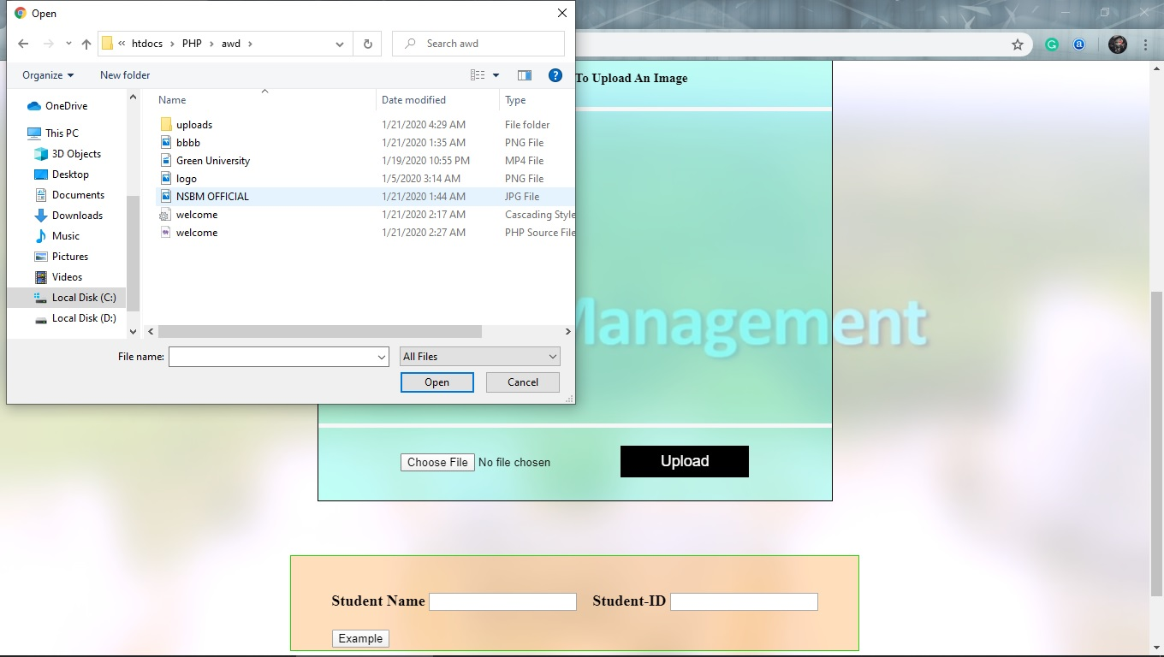

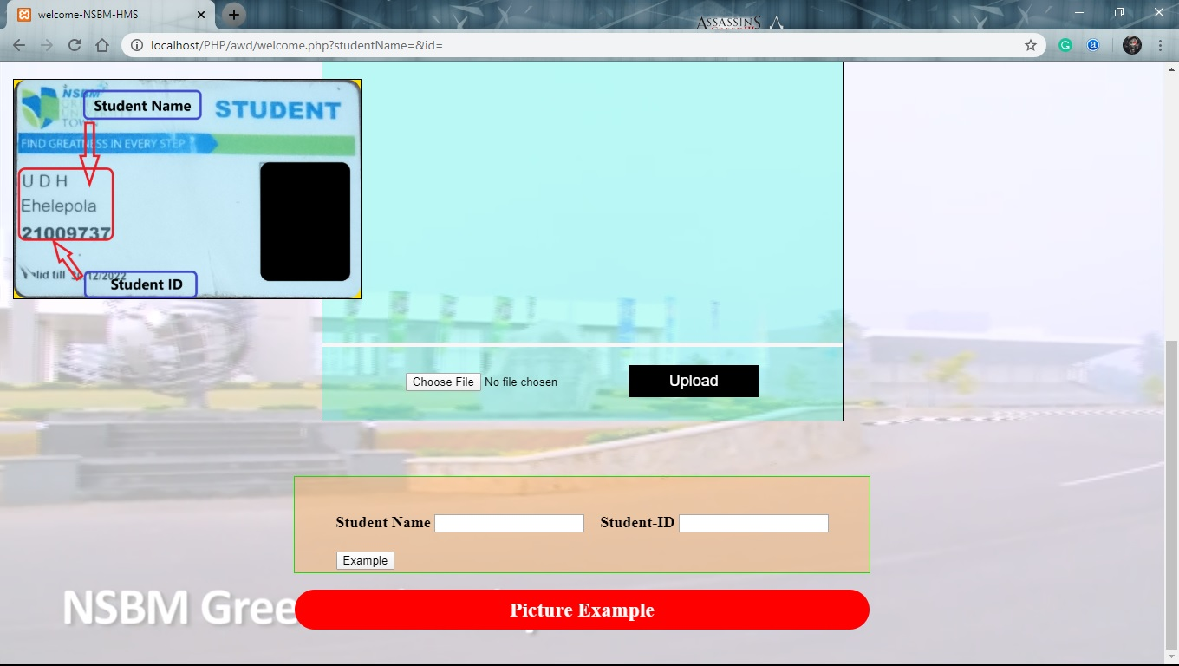

2nd step:

Send the uploaded image.

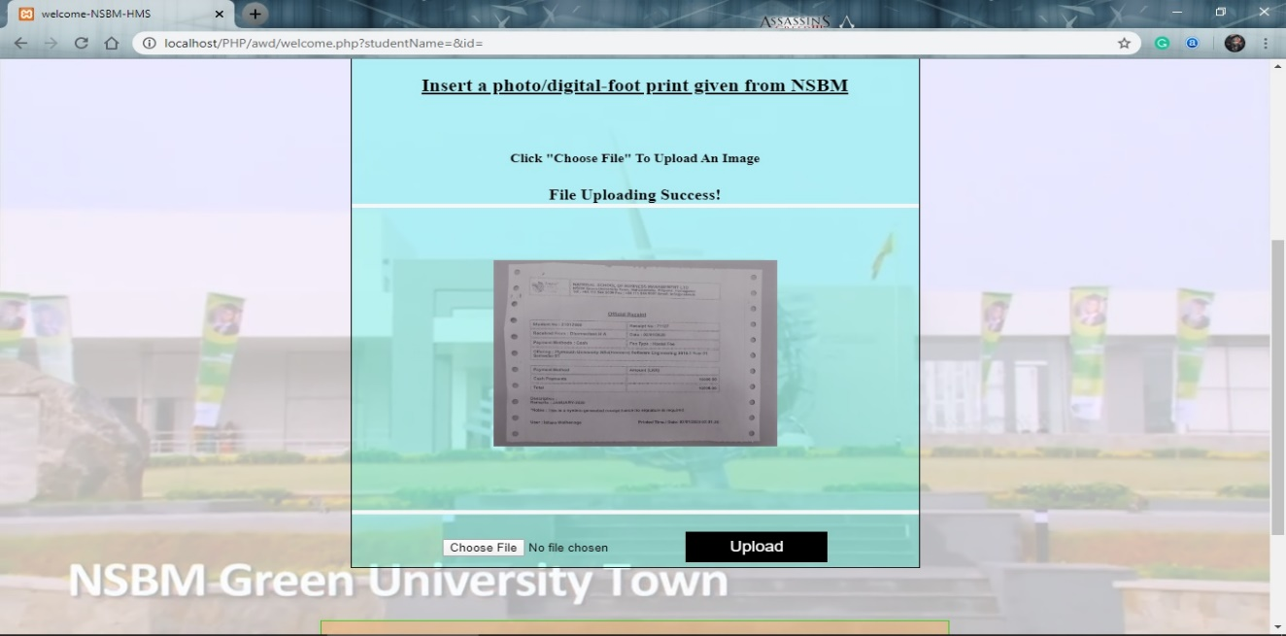

* reasonable awareness to the students about the student accommodations inside the University premises.

## Contact-us page.

## 

* **Aim of this page:**

This page will provide immediate contact between the warden and the enrolled students or the guardians of the student.

* The basic layout of the header section is present in this page as well. Other than that, there is a form to filled by students to contact the warden when needed. When this form is filled and submitted, according to the importance of the matter, warden will contact the student as soon as possible.

# Conclusion.

* We have made this project of website “hostel management system” using various tags and codes of HTML, CSS, JavaScript, and PHP. After reading this document you will get to know about the services it provides. We will hope to upgrade this website further and make it better than before.

THANK YOU!